Formation of Differential Equation
Differential Equation: An equation involving derivatives of one or more dependent variables with respect to one or more independent variables is called a differential equation.
Example: For examples of differential equation we list the following:
1. 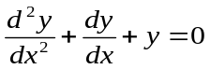
2. 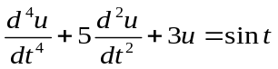
3. 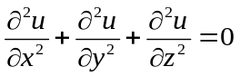
4. 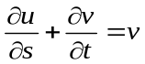
Classification: Differential equations are classified on the basis of type as follows:
- Ordinary Differential Equation (ODE),
- Partial Differential Equation (PDE).
Ordinary Differential Equation (ODE): A differential equation involving derivatives of one or more dependent variables with respect to only one independent variable is called an ordinary differential equation.
Example: 1. 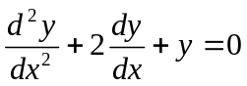
2.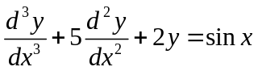
Partial Differential Equation (PDE): A differential equation involving derivatives of one or more dependent variables with respect to more than one independent variable is called a partial differential equation.
Example: 1.
2. 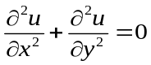
Order of a differential equation: The order of the highest ordered derivative involved in a differential equation is called the order of the differential equation.
Example: 1. 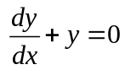 is a first order differential equation.
2. 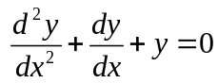 is a second order differential equation.
Degree of a differential equation: The power of the highest ordered derivative involved in a differential equation is called the degree of the differential equation, after the equation is freed from radicals and fractions in its derivatives.
Example: 1. is a differential equation of first degree.
2. 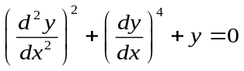 is a differential equation of second degree.
3. 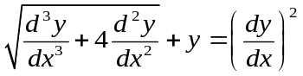is a differential equation of first degree.
Linear ordinary differential equation: An ordinary differential equation of order n is called a linear ordinary differential equation of order n if it does not contain,
- the transcendental functions of dependent variable,
- the product of dependent variable and
- the product of the derivatives of dependent variable.

It can be expressed as
where, 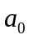 is not identically zero.
Example: 1. 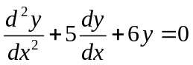
2. 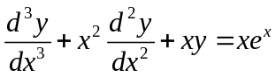
Nonlinear ordinary differential equation: A nonlinear ordinary differential equation is an ordinary differential equation that is not linear.
Example: 1. 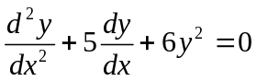
2. 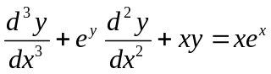
3. 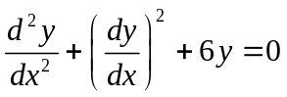

Application of differential equation: Some applications of differential equation are given below:
- The problem of determining the motion of a projectile, rocket, satellite or planet.
- The problem of the conduction of heat in a rod or wire in a slab.
- The problem of determining the vibrations of a wire or a membrane.
- The study of the rate of decomposition of a radioactive substance or the rate of growth of a population.
Problem-01: Form the differential equation of the complete integral 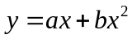.
Solution: Given that,
… … ... (1)
Differentiating (1) with respect to we get,
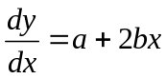 … … … (2)
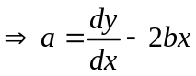
Again differentiating (2) with respect to we get,
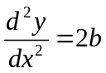
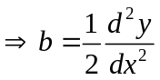
Putting these values of ‘’ and ‘’ in the equation (1) we have,
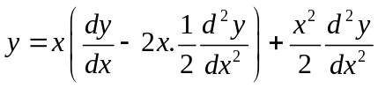
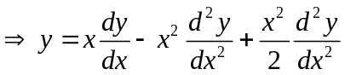
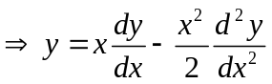
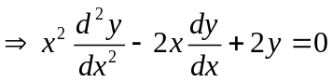
which is a differential equation of second order and first degree.
Problem-02: Form the differential equation of the complete integral 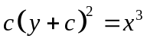.
Solution: Given that,
… … … (1)
Differentiating (1) with respect to we get,
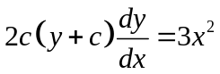… … … (2)
Dividing (1) by (2) we get,
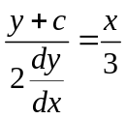
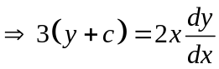
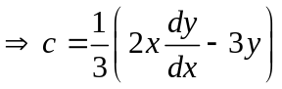
Putting this value of ‘’ in the equation (2) we get,
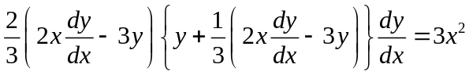
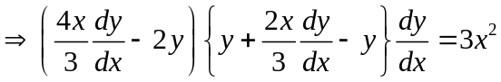
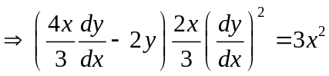
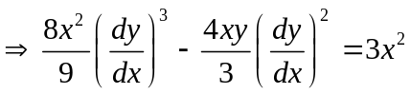
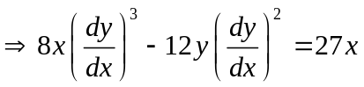
which is a differential equation of first order and third degree.
Problem-03: Find the differential equation from the relation 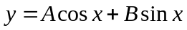
where  and  are arbitrary constants.
Solution: Given that,
… … … (1)

Differentiating (1) with respect to we get,
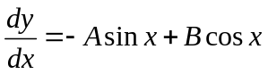 … … … (2)
Again, differentiating (2) with respect to we get,
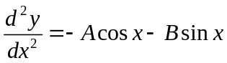
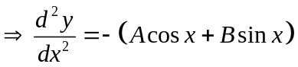
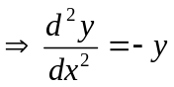
which is a differential equation of second order and first degree.

Problem-04: Find the differential equation of the family of curves , 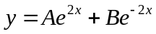 for different values of and .
Solution: Given that,
… … … (1)
Differentiating (1) with respect to we get,
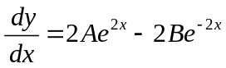 … … … (2)
Again, differentiating (2) with respect to we get,
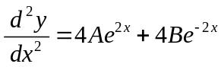
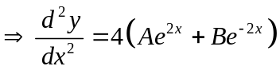
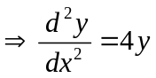
which is a differential equation of second order and first degree.
Problem-05: Find the differential equation from the relation 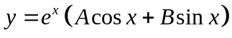
where and are arbitrary constants.
Solution: Given that,
… … … (1)

Differentiating (1) with respect to we get,
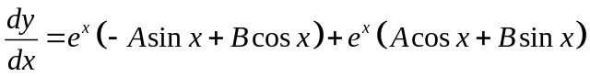
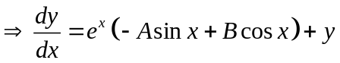
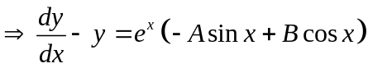 … … … (2)
Again, differentiating (2) with respect to we get,
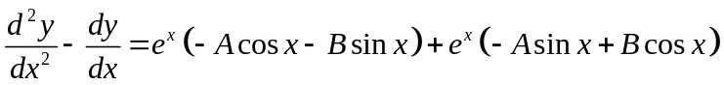
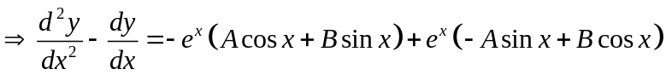
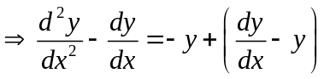
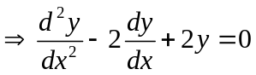
which is a differential equation of second order and first degree.
Problem-06: Find the differential equation of the complete integral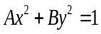for different values of and .
Solution: Given that,
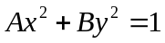 … … … (1)
Differentiating (1) with respect to we get,
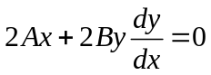
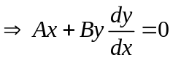 … … … (2)
Again, differentiating (2) with respect to we get,
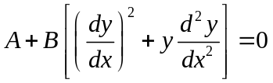
Multiply above equation by we get,
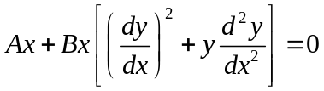… … … (3)
Subtracting equation (2) from equation (3) we get,
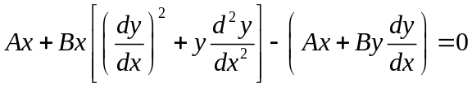
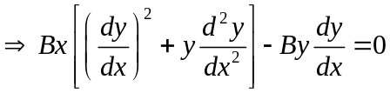
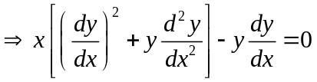
which is a differential equation of second order and first degree.
Exercise: Form the differential equations for the following equations:
1. 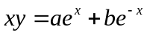
2. 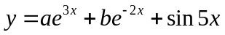
3. 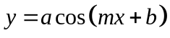
4. 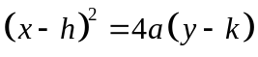
5. 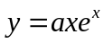
6. 